|  |
| --- |
| **Заказчик:** |
| **Имя:** |
| **Телефон:** |
| **Почта:** |



|  |
| --- |
| **ООО «Авиком-Пласт»**  Россия, г. Волгоград, 400011,  ул. Электролесовская, 35,  Тел.: 8 (8442) 49-36-31 |

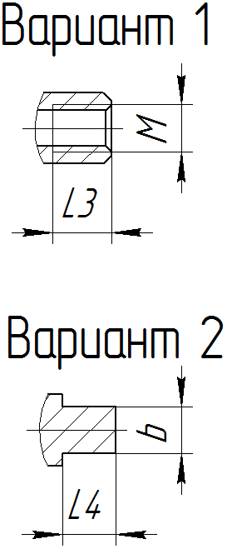

**Опросный лист для заказа приводных конвейерных роликов**

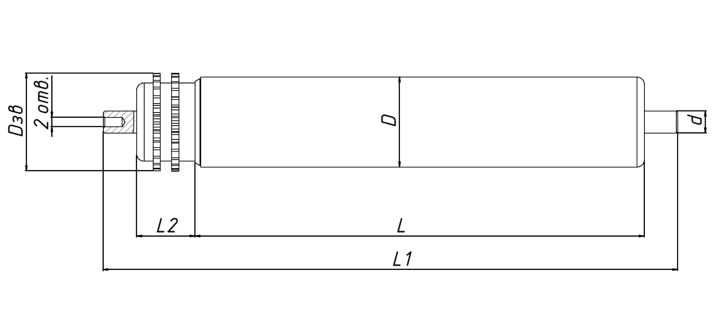

**Варианты исполнения осей**

|  |  |
| --- | --- |
| 1. Внутренняя резьба | 1. Лыска двухсторонняя |

|  |  |  |  |  |  |  |  |  |  |  |  |  |  |
| --- | --- | --- | --- | --- | --- | --- | --- | --- | --- | --- | --- | --- | --- |
| **Исполнение оси** | **D** | **L** | **L1** | **L2** | **d** | **Dзв** | **l** | **M** | **S** | **Материал оси** | **Обечайка**  (материал) | **Подшипник**  (материал) | **Кол-во** |
|  |  |  |  |  |  |  |  |  |  |  |  |  |  |
|  |  |  |  |  |  |  |  |  |  |  |  |  |  |
|  |  |  |  |  |  |  |  |  |  |  |  |  |  |

**Дополнительная информация ( здесь вы можете уточнить покраску, исполнение, вид цепи и тд.): ___________________________________________________________________________________________________________________________________________________________________________________________________________________________________________________________________________________________________________________________**